Pokhara University

Level: Bachelor | Semester – Fall | Year : 2012
Programme: BE |  | Full Marks: 100
Course: Numerical Methods |  | Pass Marks: 45
 |  | Time : 3hrs.

Candidates are required to give their answers in their own words as far as practicable.
The figures in the margin indicate full marks.

Attempt all the questions.

 | - Find the roots of the equation by using Newton Raphson method.  f(x) = x-1.5 sinx – 2.5 = 0  - Find the root of the equation xe^{x}=cosx using the false position method, correct to 3 decimal places. | 7  8
 | - Find a real root of 2x – log₁₀x = 7 correct to four decimal places using fixed point iteration method.  - The following table gives the population of a town during the last six census. Estimate using Newton's interpolation formula, the increase in population during the period 1946 and 1948 | 7  8
  Year | 1911 | 1921 | 1931 | 1941 | 1951 | 1961
  Population (in 000) | 12 | 13 | 20 | 27 | 39 | 52
 | - The pressure and volume of a gas are related by the equation  PV^{γ}=C, ^{γ} and C being constants. Fit this equation to the following set of observations.  OR  Find the missing values of the following table  By Trapezoid and Simpson’s rules  - Evaluate | 7  7  8
  P(kg/cm²) | 0.5 | 1.0 | 1.5 | 2.0 | 2.5 | 3.0
  V (litres) | 1.62 | 1.00 | 0.75 | 0.62 | 0.52 | 0.46
   | 0 | 1 | 2 | 3 | 4 | 5 | 6
   | -4 | -2 | - | - | 220 | 546 | 1148
 | - Break the following matrix into [L] and [L^{T}],where [L] is a lower triangular matrix and [L^{T}] is transpose of [L]  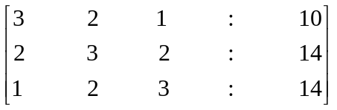  - Determine the largest eigenvalue and the corresponding eigenvector of the matrix: A=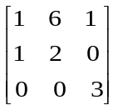using the power method. | 7  8
 | - Find the inverse of the matrix by using Gauss Jorden method.  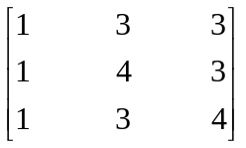  - The mathematical model of an electrical circuit is given by  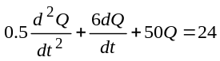sin 10t with Q(0)=0 and Q'(0)=0,  then find Q (0.2) and Q' (0.2) by fourth order Runge-Kutta method then find Q (0.2) and Q' (0.2) by fourth order Runge-Kutta method | 7  8
 | - Using Euler’s method. Find an approximation vaue of y corresponding to x= 1.04 given 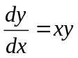and y = 1 when x = 1.  - Give the values of u(x,y) on the boundary of the square given in figure, evaluate u(x,y) satisfying Laplace equation ²u=0 at the pivoted points of this figure  1000 1000 1000 1000  1000 500 0 | 7  8
  2000 |  | u₁ | u₂ | 500
  2000 |  | u₄ | u₃ | 0
 | Write short notes on any two:  - Romberg Integration Method  - Shooting method  - Laplician equation | 2×5

